`

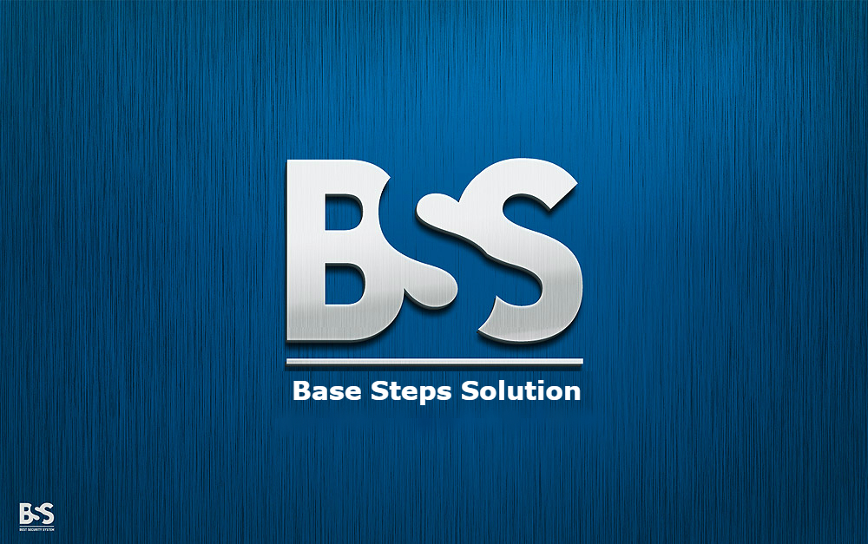

Meeting Minutes

Van Lang Admissions

# Revision Table

|  |  |  |  |
| --- | --- | --- | --- |
| Author | Date | Reason for changes | Version |
| Khoi Nguyen | 24/10/2016 | Initial Document | 1.0 |

Table of Contents

Revision Table 1

1 Purpose of meeting: 3

2 Participants in meeting 3

3 Content 3

4 References 4

5 Note 4

6 To Do Tasks 4

7 Next meeting 4

|  |  |  |  |  |  |
| --- | --- | --- | --- | --- | --- |
| **Writer:** | Nguyễn Anh Khởi | **Location:** | 7 Floor of Van Lang university | | |
| **Date:** | **24/10/2016** | **Start:** | 10h50 | **Finish:** | 12h |

|  |
| --- |
| Purpose of meeting: |
| * Review Process * Discuss about requirement phase , how to get requirement of customer |

|  |  |  |  |
| --- | --- | --- | --- |
| Participants in meeting | | | |
| Name | Role | E-mail | Phone |
| Lê Sĩ Phú | Mentor | lesiphu@vanlanguni.vn | 0986982003 |
| Nguyễn Thái Hiền | Leader | hiennguyenthai93@gmail.com | 0937398353 |
| Trần Xuân Hải | Member | haitran2402@gmail.com | 01662542331 |
| Nguyễn Anh Khởi | Member | nguyenanhkhoicntt@gmai.com | 0933408603 |
| Đoàn Anh Minh | Member | minhdoan414@gmail.com | 01284144641 |
| Nguyễn Hoàng Anh Tài | Member | nguyenhoanganhtai95@gmail.com | 01203244599 |
| Nguyễn Xuân Thái Hiền | Member | bs.gtts44@gmail.com | 0974949241 |

|  |
| --- |
| Content |
| - Review incremental process  + Prototype -> Concept  + Output of Architeture , what step after Architeture?  + Where are release of Requirement phase?  + Where is System test ?  + Need to reseach and re-define process  - Discuss about requirement phase  + Discuss about how to get requirement of customer  + Need to get business goal , mission goal  + Specially at vision , scope  + Get clearly about contrains , business function  + Get core value to limit scope |

|  |
| --- |
| References |
|  |

|  |
| --- |
| Note |
| - Update document  - Meeting with Customer at 26/10/2016 |

|  |  |  |  |  |
| --- | --- | --- | --- | --- |
| To Do Tasks | | | | |
| **#** | **Task** | **Start date** | **Completion date** | **Status** |
| 1 | Update Project Plan | 24/10/2016 | 4/11/2016 | High |
| 2 | Update Processes | 24/10/2016 | 4/11/2016 | High |
| 3 | Prepare question to get requirement | 24/10/2016 | 26/10/2016 | High |
| 4 | Learn software development ( Nodejs , MongoDB , AngilarJS … ) | 24/10/2016 | 4/11/2016 | Medium |

|  |  |  |  |
| --- | --- | --- | --- |
| Next meeting | | | |
| **Date: 8/11/2016** | **Content:** | **Time: 10h** | **Location: Redsun Company** |
| **Writer:** | Nguyễn Anh Khởi | | |

---- *** ----